**In our prayers:**

**Our service men and women, especially** JT Cole, Larry Halpin, and Nicholas Bierly.

**Our members and others who are homebound, including:** Grace Hazel, Linda Hettinger, and Mary Wolfe.

**Our members and friends who are sick, hospitalized, and in urgent medical need, and all caregivers.** Chip Hoover, Hailey Gates, Donna Guisewite,.Muhammed Oweis

**People experiencing ongoing, long term sickness,** especially Cathy Antes, Donna Auman, Carol Bain, Gerald Bair, Vera Bair, Betty Bartges, Mary Berger, Clarissa, Linda Bryan, Judy Burns, Michele C, TJ Coursen, Melissa Diminick, Chris Evangelista, Dorothy Godfrey, Aryk, Tim Halpin, John Harbuck, Linda Hettinger, Michael Curtis Hodges, Shannon Hodges, Risa Holmes, Ron Horner, Patti Houck, Blake Hull, Candace Hutchinson, Eunice Jeffries, Lauren Kauffman, Art Kirkby, Colman Krise, Kris, Larry Kuhns, Dorothy Lilien, Lauren M., Tylee McClenahan, Roger Meyer, Lauren M., Cindy Manley, Kristin Markham, April Marquardt, Kim Marsh, Mary, Kathy McCool, Mary Beth Morris, Steve Muller, Nate, Irwin Rhode, Carla Rodgers, Shawn, Claire Shaw, Brenda Stover, Ellen Strouse Paula Ward, Tessa Watson, TJ, Don Wenner, Heather Wise, Henry White, Cathy Zettle,

**People experiencing substance use disorder and emotional or mental health issues,**

**especially those stressed in these uncertain times. People considering suicide.**

**People who are oppressed, exploited, trafficked and abused, especially children.**

**People who are grieving,** especially family and friends of Ruth Schultz

**People who are refugees and homeless. Victims of terrorism and hate crimes.**

**People who experience natural disasters.**

**Recipients of our prayer shawls.**

**Children who are sick and have special needs and their families:** especially Colin, Connor, Kaelyn, Ruby, Zoey and Logan Paul.

**People who are incarcerated and those who minister to them.**

**All those sick from Covid-19, and long-haulers, and those who care for them,** especially Harold DeLooze, Jason Dominick, Gavin Greenawalt, Gary Trahan, and the Oweis family.

**Opportunities for Mission!**

**Church World Service:** Needs Health Kits to help people worldwide adequately wash and care for themselves. Consider filling one. A list of items is included in the bulletin once a month; drop the completed kit in any of our churches. Pastor Julie does regular pick up and shipping. You can also make a donation and leave the shopping to CWS.

**Local Food Pantries:** Leave donations for local food pantries in any church, or on the porch of the parsonage. Juices, fruit and paper products are needed. Pastor Julie picks up from the churches and deliver about every second or third Tuesday.

**Please do not forget your church in these trying times! To donate:**

**Christ UCC:** Lois Miller, PO Box 124 Madisonburg, PA 16852

**St. Peter’s UCC/Brush Valley Fusion of Faith:**

Beth Haas, 251 View Drive Rebersburg, PA 16872

**St. Peter’s Lutheran:** PO Box 164, Rebersburg, PA 16872



**Easter Sunday**

**April 4, 2021**

**Welcome!**

**Welcome to the Brush Valley Fusion of Faith, an ecumenical spiritual community in Brush Valley. Our churches include St. Peter’s UCC in Rebersburg, St. Peter’s Lutheran in Rebersburg, Christ UCC in Madisonburg, and Brush Valley Messy Church. We are glad to have you with us today, whether you are a first-time visitor or a lifelong member!**

**Service Credits:**

Today’s Service is from *Evangelical Lutheran Worship,* ©2006 Evangelical Lutheran Church in America and *Sundays and Seasons, Year C 2016* ©2015 Augsburg Fortress Press. Used by permission of 1517 Media under Annual Liturgies License #SB098686.

Scripture readings Copyright © 2012 by Common English Bible and/or its suppliers. Used by Permission. All rights reserved.

Hymns which are not public domain are reprinted and streamed under OneLicense.net A-720761.

Our Father by Chad Steffey, ©MerciaMusic 2014, used by permission

***We are currently worshipping remotely. We will restart in person when the test positivity rate in Centre County is below 5% and we are in vaccine distribution phase 2. We will continue online worship even when we are back in the building. WORSHIP STARTS AT 8:45 in March and April. Call starts at 8:30.***

***Each church has a log and a hand sanitizer station. If you go into the church for any reason, please record your visit, in case of an outbreak that affects our community and need to support contact tracing. There are also antiseptic wipes at the churches.***

**Thrive DC** needs socks, underwear (all sizes, solid colors) and travel size toiletries. Backpacks /Tote Bags (even used!) are also useful. Drop in the churches, or on Pastor Julie’s porch.

**Out of the Cold** houses homeless people from our churches. Volunteers and meals are needed. Overnight and Host (8-11 PM) volunteers needed. Contact Pastor Julie.

We also support the **Food Pantry at the Aaronsburg Outreach Center**. Please bring groceries by your church or drop at the parsonage before our Tuesday delivery.

**Brush Valley Fusion of Faith**

St. Peter’s Lutheran, Rebersburg

Christ UCC, Madisonburg, St. Peter’s UCC, Rebersburg

Pastor: Julie Holm

Secretary: Catherine Nelson

Church Office Phone: (814)-349-5515

Parsonage Phone: (814)-359-6883/**Pastor’s cellphone: (703)-887-1265**

Pastor’s email : [julie@bvfof.org](mailto:julie@bvfof.org) / Secretary’s email : secretary@bvfof.org

Website [*www.bvfof.org*](http://www.bvfof.org) *Facebook: www.facebook.com/BVFOF*

**This Week in the Rebersburg Parish:**

**SPL= St. Peter’s Lutheran, SPU = St. Peter’s UCC, CU= Christ UCC**

Sunday, April 4: 7:00 AM – Sunrise Service, Methodist cemetary.

8:45 AM – Worship via Conference Call

Tuesday, April 6: 7:00 PM – Book Group – Bell Chapters 18-20

Sunday, April 11: 8:45 AM – Worship via Conference Call (Palm Sunday!)

2:00 PM – Penn Central Conference Annual Meeting

Upcoming Events:

* April 13 – Bible Study: Acts 6:1-7:2a, 44-60, Acts 8:26-39
* April 14 – Council Meeting – 7:00 PM
* May 2 – Outdoor Communion Service, if we are not yet indoors

*We are using the Narrative Lectionary.*

*A bookmark with readings for the year is available by request from the pastor.*

**Conference Call information for all conference calls:**

**Dial: One Number: (609) 663-4205** The simplest way to get in. You do NOT need an access code, just call this number. It IS long distance!

**OR: (978) 990-5000** for cellphones, and if you have unlimited long distance

**(844) 855-4444** if you have to pay by the minute for long distance calls

OR if the other number will not work.

The recording will ask for an access code. You dial: **237235#**

**If you get disconnected, call in again!**

The line will be open by 15 minutes before a service or 10 minutes before bible/book study.

*For everyone’s benefit, please mute yourself (*6 on most phones) during hymns.*

**Online Worship** (Same meeting as the phone, audio only, but better audio!)

Go to [*http://join.freeconferencecall.com/jholm4*](http://join.freeconferencecall.com/jholm4)in your browser

Worship will also be available live via Facebook, when possible, on the Brush Valley Fusion of Faith page, as of 2/28. Mark “going” to the events to receive reminders and updates on the services. FB services are then saved and available online.

**Delegates are needed** for ONLINE Meetings of the Allegheny Synod (June 4-5) and the Penn Central Conference (June 12), the Nittany Conference caucus (date TBD) and the Northern Association Annual Meeting (April 11 – Zoom and phone, 3 hours) Contact a Council Member or Pastor Julie if you are interested. We will be electing a Bishop in the synod this year!

**The UCC National Synod** will be held online from July 11-18. If you’ve never been to a National Synod, this year is your opportunity to do so from your living room, or from your church, if gathering together is an option! More information coming!

**Thanksgiving for the Word**

One: Praise and thanks to you, holy God, for by your Word you made all things: you spoke light into darkness, called forth beauty from chaos, and brought life into being. For your Word of life, O God,

**All: we give you thanks and praise.**

One: By your Word you called your people Israel to tell of your wonderful gifts: freedom from captivity, water on the desert journey, a pathway home from exile, wisdom for life with you. For your Word of life, O God,

**All: we give you thanks and praise.**

One: Through Jesus, your Word made flesh, you speak to us and call us to witness: forgiveness through the cross, life to those entombed by death, the way of your self-giving love. For your Word of life, O God,

**All: we give you thanks and praise.**

One: Send your spirit of truth, O God; rekindle your gifts within us: renew our faith, increase our hope, and deepen our love, for the sake of a world in need. Faithful to your Word, O God, draw near to all who call on your; through Jesus Christ, our Savior and Lord, to whom, with you and the Holy Spirit, be honor and glory forever.

**All: Amen.**

**Lord’s Prayer** Insert

**Announcements**

**Blessing**

One: The Lord bless you and keep you.

The Lord’s face shine on you with grace and mercy.

The Lord look upon you with favor and give you peace.

**All: Amen.**

**Sending Hymn** *The Strife is O’er*Insert

**Dismissal**

One: Alleluia. Go in peace. Share the good news.

**All: Thanks be to God. Alleluia.**

4

**Brush Valley Fusion of Faith Phone service**

**April 4, 2021** – Narrative Lectionary, week 32

Easter Sunday!

**GATHERING**

**Prelude**

**Thanksgiving for Baptism**

One: Blessed be the holy Trinity, one God, the fountain of living water, the rock who gave us birth, our light and our salvation

**All: Amen.**

One: Joined to Christ . . . . . . in the unity of the Holy Spirit, now and forever.

**All: Amen.**

**Gathering Hymn** *Jesus Christ is Risen Today* Insert

**Thanksgiving for Baptism**

One: Blessed be the holy Trinity, one God, the fountain of living water, the rock who gave us birth, our light and our salvation

**All: Amen.**

**Prayer of the Day**

One: . . . Jesus Christ our loving Lord. **All: Amen.**

**WORD**

**Psalm 118:17, 21-24**

One: I won’t die—no, I will live and declare what the Lord has done.

**All: I won’t die—no, I will live and declare what the Lord has done.**

One: I thank you because you answered me, because you were my saving help.

**All: I won’t die—no, I will live and declare what the Lord has done.**

One: The stone rejected by the builders is now the main foundation stone!

**All: I won’t die—no, I will live and declare what the Lord has done.**

One: This has happened because of the Lord; it is astounding in our sight!

**All: I won’t die—no, I will live and declare what the Lord has done.**

One: This is the day the Lord acted; we will rejoice and celebrate in it!

**All: I won’t die—no, I will live and declare what the Lord has done**

1

One: The holy gospel according to Luke

**Many: Glory to You, O Lord.**

**Narrative Lectionary Reading**  Luke 24:1-12

One: The gospel of the Lord.

**Many: Praise to You, O Christ.**

**Sermon**

**Hymn of the Day *That Easter Day with Joy Was Bright*** Insert

**Nicene Creed**

**We believe in one God,**

**the Father, the Almighty,**

**maker of heaven and earth,**

**of all that is, seen and unseen.**

**We believe in one Lord, Jesus Christ,**

**the only Son of God,**

**eternally begotten of the Father,**

**God from God, Light from Light,**

**true God from true God,**

**begotten, not made,**

**of one Being with the Father;**

**through him all things were made.**

**For us and for our salvation**

**he came down from heaven,**

**was incarnate of the Holy Spirit and the virgin Mary**

**and became truly human.**

**For our sake he was crucified under Pontius Pilate;**

**he suffered death and was buried.**

**On the third day he rose again**

**in accordance with the scriptures;**

2

**he ascended into heaven**

**and is seated at the right hand of the Father.**

**He will come again in glory**

**to judge the living and the dead,**

**and his kingdom will have no end.**

**We believe in the Holy Spirit, the Lord, the giver of life,**

**who proceeds from the Father and the Son,**

**who with the Father and the Son is worshiped and glorified,**

**who has spoken through the prophets.**

**We believe in one holy catholic and apostolic church.**

**We acknowledge one baptism for the forgiveness of sins.**

**We look for the resurrection of the dead,**

**and the life of the world to come. Amen.**

**Prayers of Intercession**

**Response:**

One: Hear us, O God

**Many: Your mercy is great.**

**At the end:**

One: . . . can be a source of much needed encouragement.

In Jesus’ name we pray.

**Many: Amen.**

**The Peace**

**Dedication of Offerings**

**Blessed are you, O God, ruler of heaven and earth.**

**Day by day you shower us with blessings.**

**As you have raised us to new life in Christ,**

**give us glad and generous hearts,**

**ready to praise you and to respond to those in need,**

**through Jesus Christ, our Savior and Lord. Amen.**

**3**

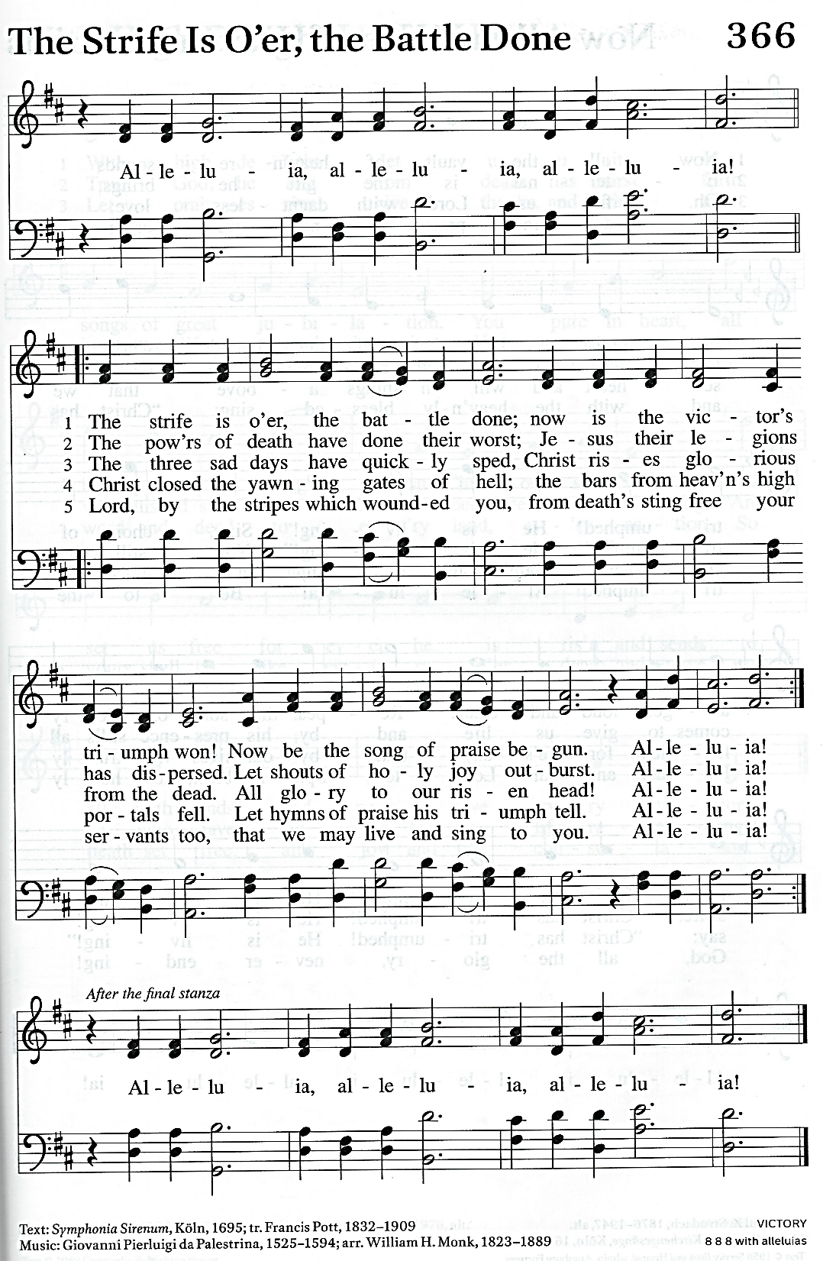

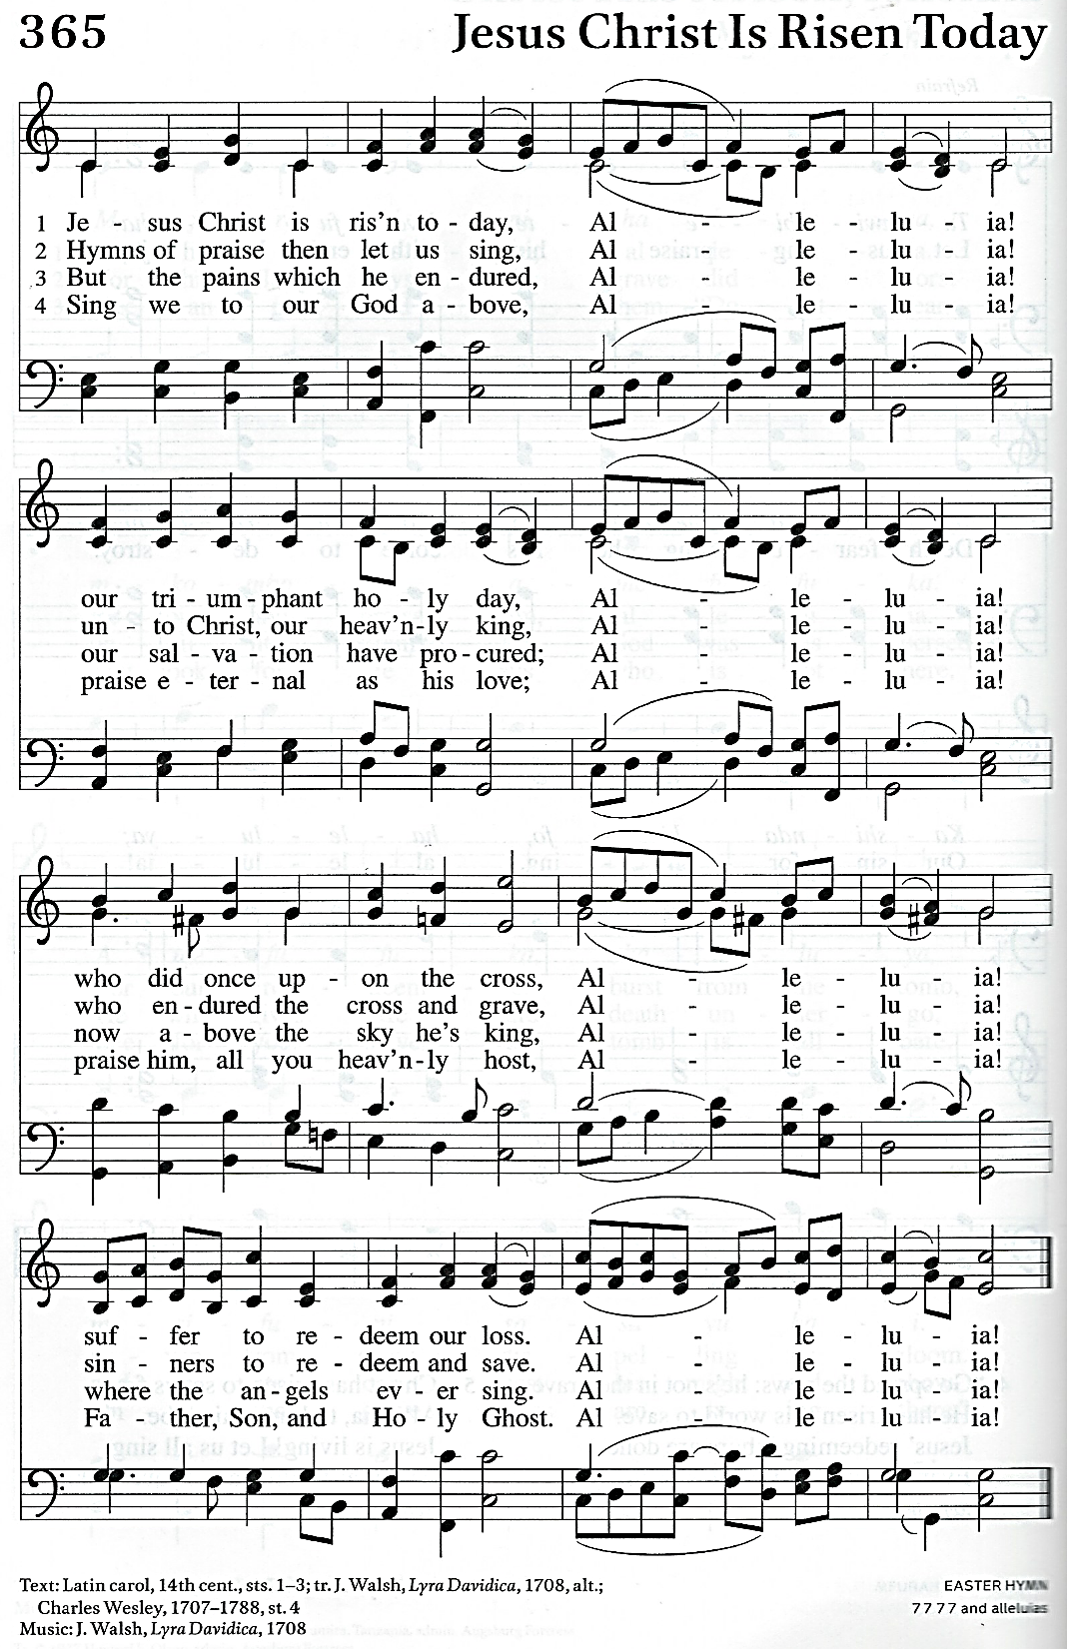

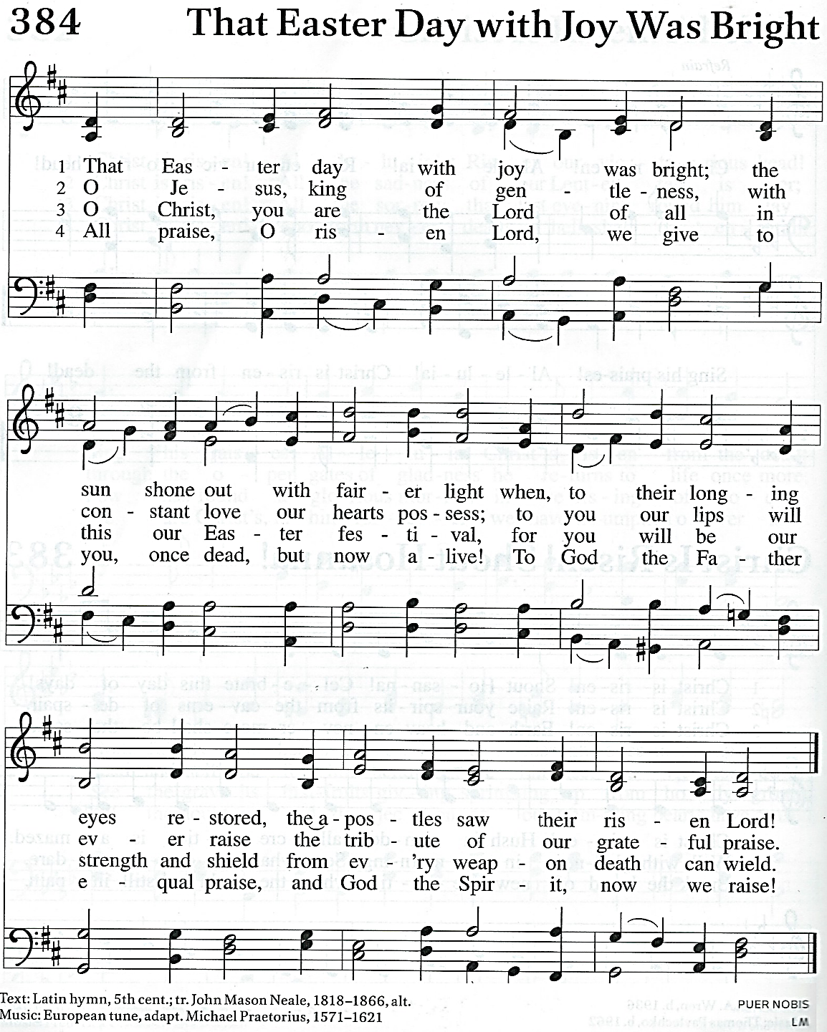

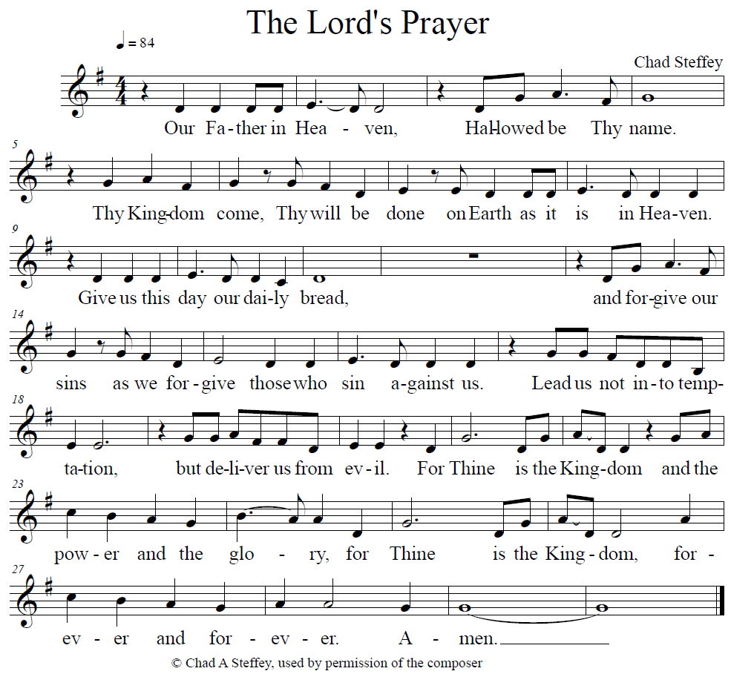



Help the Dove get to the cross.

Children’s Bulletin

Narrative Lectionary Year 3 Week 30

Easter Sunday! April 4, 2021



It is Easter Sunday! The Church loves to celebrate!

Children are welcome in our churches whenever we are at worship. We understand

they are not always quiet. While we are worshipping on the phone we are

providing these bulletins for parents to use at home.

*A separate, Holy Week children’s bulletin has been enclosed as well. We encourage you to share it with your children on their Friday day off from School.*





Pastor page

**Thanksgiving for Baptism.**

Joined to Christ in the waters of baptism, we are clothed with God’s mercy and forgiveness.

Let us give thanks for the gift of baptism.

*Water may be poured into the font.*

We give you thanks, O God,

For in the beginning your Spirit moved over the waters

And by your Word you created the world, Calling forth life in which you took delight.

Through the waters of the flood you delivered Noah and his family.

Through the sea you led your people Israel from slavery into freedom.

AT the river your son was baptized by John and anointed with the Holy Spirit.

By water and your Word you claim us as daughters and sons,

Making us heirs of your promise and servants of all.

We praise you for the gift of water that sustains life,

And above all we praise you for the gift of new life in Jesus Christ.

Shower us with your Spirit, And renew our lives with your forgiveness, grace, and love.

To you be given honor and praise Through Jesus Christ our Lord

In the unity of the Holy Spirit, now and forever.

Amen.

**Prayer of the Day:** Risen Messiah ,Hallelujah! Christ is risen! Christ is risen indeed! Glory be to you, whom death could not defeat. Praise to the savior of heaven and earth. Honor and glory areyours, now and forever, Christ our savior and redeemer. Amen

Prayers for Others and Ourselves

Living God,

we praise you this Easter Day.

Your generosity has gifted us this feeling we enjoy today

and the confidence we take from knowing ourselves loved so completely.

We have been filled with deep hope.

We thank you for the generosity unfolding in your heart that led to Jesus’ birth.

For the wisdom of his words and the actions

that revealed your character to our understanding.

We thank you that Jesus was brave and selfless and that he had the strength

to fulfil a life of unswerving devotion to your Way

even when the cost came with hammers and nails.

We thank you that the cross was not the end

and the tomb not a ‘final’ resting place;

but instead opened up the possibility

of Jesus’ ongoing Lordship over all of creation.

We thank you for the work of the Holy Spirit

that breathes the life,

that has its origin in the emptiness of the tomb,

far and wide throughout the human family today.

Today we recognize that sadly there is much darkness

in the world that remains seeking the light of your love.

Today we pray for the places where war, terror,

poverty and injustice still exist. Hear Us O God, **YMIG**

We pray for those whose winter has been harsh

and where food is in short supply.

We pray for those for whom the southern summer

has been so dry and consuming

that fields remain in much need of water now,

and lacking necessary irrigation. Hear Us O God, **YMIG**

Today we pray for those who bear challenges

that extinguish all ability to live hopefully.

We pray for those abused by those who should be loving them.

We pray for those enduring grief

and those suffering from loneliness. Hear Us O God, **YMIG**

We pray for those who face an uncertain future—

the result of the pandemic and other constraints

within the economy and job market. Hear Us O God, **YMIG**

Lord of light that overcomes darkness,

let your work continue in the world.

May you touch the lives of those who need support

and continue to direct us to those for whom our own love

can be a source of much needed encouragement.

In Jesus’ name we pray. Amen.